Smartwatch tracking app

Author: Mikołaj Moskal

Date: 18.1.2018
Abstract

Goal of project is to create application, that will allow user to track his wearable devices. Application is supposed to generate map based on google maps engine, with drawn route and points, where device, that is being tracked was. Maps will be updated in real time, showing defined by user amount of most recent points with date of recording, and if user would like to keep eye on the latest point, Application will do it for him after selection of this option in option bar.

Requirements

Must have | Should have | Could Have | Won’t have
Working location storing mechanism | Unnoticeable  smartwatch background app | Solid authorization system | Multi OS support
Pretty device tracking screen | Low battery consumption | Fit features | Another wearable devices support
Login system |  | Generating user statistics feature
 |  | Anti-theft feature
 |  | Smartphone friendly web app

Main scenario

- User runs background application on smartwatch
- Application sends device location to server
- User runs tracking application on web browser
- Login into web application
- User selects device to track
- Program displays map with wearable device locations over the time
Use cases

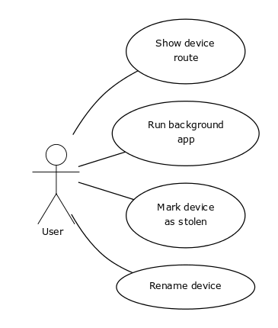
Diagram 1. Use case diagram

Use cases description

Code | UC-1
Name | Show device route
Actors | User
Initial condition | Internet connection
Description | 1.User runs application  2.User logs in  3.User selects device  4.User clicks show route  5.Application generates map with route on it
Alternative | 3A User adds new device

Code | UC-2
Name | Run background app
Actors | User
Initial condition | Internet connection  Device location turned on
Description | 1.User runs background application  2.Device gathers location  3.Device sends location to server
Alternatives | 2A Location is turned off  3A Error with internet connectivity

Code | UC-3
Name | Mark device as stolen
Actors | User
Initial condition | Internet connection
Description | 1.User runs application  2.User selects device  3.User clicks mark device as stolen  4.Application sends information to server
Alternatives | 2A User adds new device  4A Error with internet connectivity

Code | UC-4
Name | Rename device
Actors | User
Initial condition | Internet connection
Description | 1.User runs background application  2.User goes into settings  3.User selects rename device option  4.User selects new name  5.User hit apply button  6.Application sends information to server
Alternatives | 4A Name not incorrect  6A Error with internet connectivity

